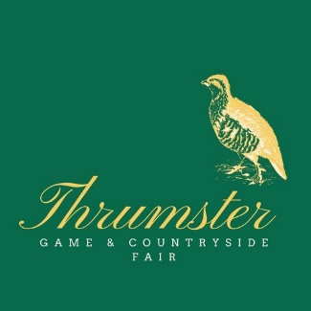

**LIVESTOCK ENTRY FORM - 16TH AUGUST 2025**

**Please note there are two pages to this form.**

|  |  |  |  |  |  |
| --- | --- | --- | --- | --- | --- |
| **Class** | **Paid**  **(£3 per entry**  **SECTIONS 1-13,**  **£2 SECTIONS 14-18)** | **Name of Animal**  **( for Cross Cattle please give description)** | | BVD negative  Herd Ind | |
|  |  |
|  |  |  | |  |  |
|  |  |  | |  |  |
|  |  |  | |  |  |
|  |  |  | |  |  |
|  |  |  | |  |  |
|  |  |  | |  |  |
|  |  |  | |  |  |
|  |  |  | |  |  |
|  |  |  | |  |  |
|  |  |  | |  |  |
|  |  |  | |  |  |
|  |  |  | |  | |
|  |  |  | | | |
| Total Entry Money |  | **PLEASE NOTE: ANY PRIZE MONEY WILL BE PAID TO THE ENTRANT UNLESS YOU INFORM US OTHERWISE – IF DIFFERENT, PLEASE INDICATE IN THE LINE BELOW**  **Name and address:_________________________________________________**  **Cheques should be made payable to Thrumster Game Fair, and sent to the Secretary, details below. Or payment may be made by BACS to, RBS PLC, Sort Code 83 26 16, Account No 10875982 . Please state your name as the online reference. Please also email enquiries@thrumstergamefair.co.uk with your name, date of payment, amount and stating ‘Livestock Entry’. Documentation will be issued just prior to the show.** | | | |
|  |  |
| Total Enclosed |  |
| Entrants Name |  | | | | |
| Address |  | | | | |
|  |  | | | | |
| Tel.No. |  | | Mobile Tel. No. | | |
| Email address  (Please print clearly) |  | | | | |
| Holding No |  | | | | |

**General Data Protection Rules**

I agree that my details about my person (name, address, telephone number and e-mail address) may be collected and electronically stored by Thrumster Game Fair for the next 5 years. The data is stored at the secretary’s address detailed below and used for the purposes of sending you information regarding Thrumster Game & Countryside Fair.

Your name and area you are from (John Smith, Thrumster) shall appear in our schedule, catalogue, website and on occasions our social media and any newspaper articles in relation to the show.

I agree that Thrumster Game Fair for the purposes mentioned above, may contact me in the following manner (please check all applicable boxes):

by e-mail by physical mail by telephone by mobile text message

**Date________ Signature_____________________________ Name____________________________**

You may withdraw the consent to the use of your personal data for means of communication and you also have the right to obtain details, amend and delete your personal data at any time by contacting the Thrumster Game Fair via e-mail: enquiries@thrumstergamefair.co.uk or in writing to the address below.

I confirm I have read Thrumster Game Fairs Rules & Regulations & Health & Safety policy, and will pay due regard to Bio-Security requirements

**Signature: _______________________________________________**

If you would like to receive the schedule by Email in the future please tick this box

Please return your completed form to the Secretary, C/o THRUMSTER HOUSE, THRUMSTER, WICK, KW1 5TX

Closing date for entries Wednesday 9th Aug 2025